2020 HVCA Annual Meeting Virtual Attendance Instructions
The board is doing this to provide everyone a chance to take part in the meeting in a manner that makes all our co-owners feel safe during these unprecedented times. This meeting is being donated to HVCA by board member Rob Lalain. HVCA needs quorum during these meetings, so we must have a majority of co-owners present to vote on all the important issues.
First, all you need to do is simply click on this link Join<https://acecloud.webex.com/join/rlalain>. If you ever get lost, look for this symbol on your toolbar or desktop of your computer and click on it. You can enter using the software that is free to download, or directly through Google Chrome. You might want to try downloading the day before or 10-15 minutes early if you have never used WebEx.
To get started, fill in your name, unit #, and email as listed below, no one but the administrator sees your email, but everyone will see your name and unit #.
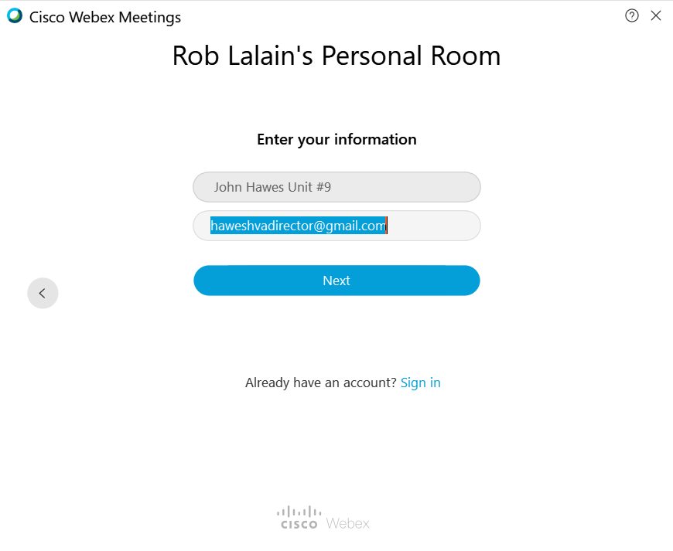

Enter your name and unit #, only those with unit # are allowed to vote. If more than one vote is cast per unit, only first vote received will count.

To your NEXT stop, you will be at this screen:
Here you have a few options, please do not turn on your camera unless you are speaking to save on bandwidth, and all co-owners will be muted until we reach the open discussion period.
Click this button to turn off your camera. When the button turns red you are off.
Click this button to mute or unmute your microphone.
Click here when you are ready to join the meeting.
If you want to use your phone to listen in, put your phone # here and the system will call you.
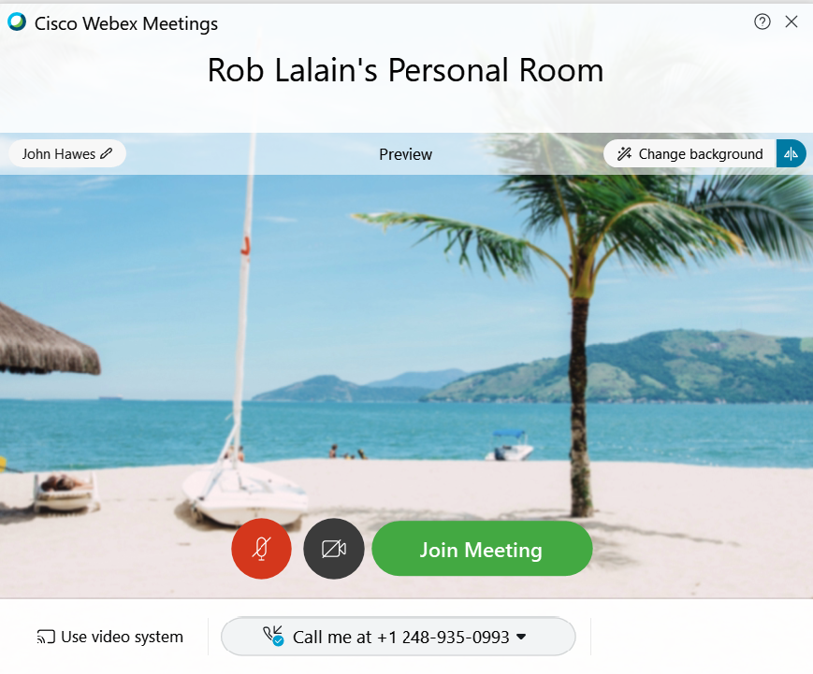

OK, you got into the meeting congratulations, now we will tell you how to navigate a few things. You need not be present to vote!
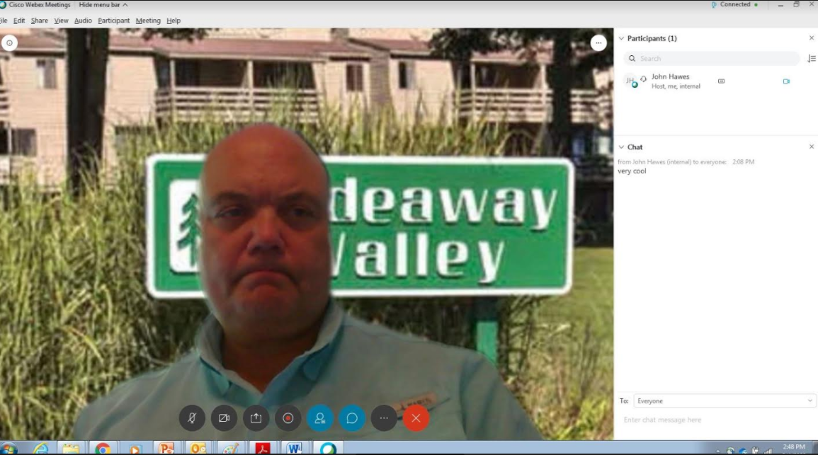

To see who else is calling in, names should be listed in small boxes on your screen, but if not just click here to see everyone.
Click this button to mute or unmute your microphone. All microphones will be muted until open discussion.
Click this button to turn on/off your camera. When the button turns red you are off.
Leave your camera off when you are not talking.
To ask a question, or to vote use the chat feature. These messages can be typed at the bottom of the chat box, hit enter when you are done typing, and can go to everyone, or a specific meeting attendee, your choice.
If you forgot to add your unit number put it in your chat message.
When you want to leave the meeting click here

